**Static Analysis of Sample Firmware**

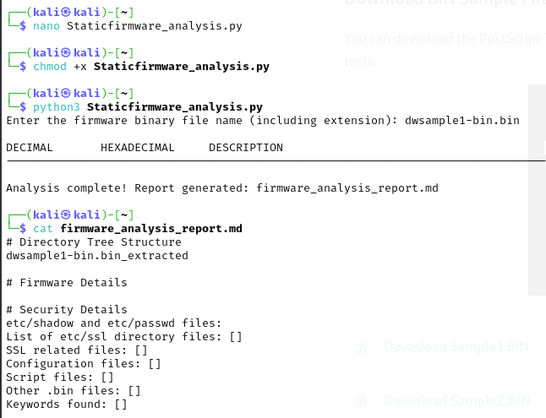

**Binary Analysis of Sample Firmware**

